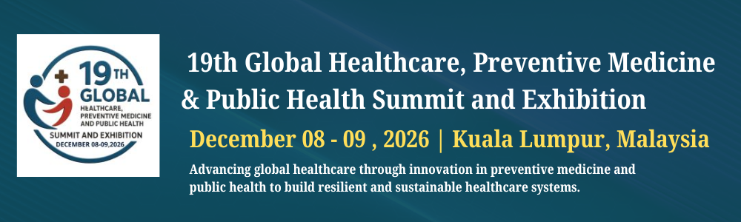
REPLACE THIS SENTENCE WITH THE TITLE OF YOUR ABSTRACT

A. B. Author¹ and C. D. Author², ¹Affiliation (include full mailing address, e-mail address and university name) for first author, ²Affiliation for second author (full mailing address, e-mail address and university name).
Introduction: Replace these instructions with the text of your abstract. Do NOT delete the section break above. The text will appear in two columns that are each ~3 inches wide. (Please make sure your paper size is set to U.S. letter, 8.5" × 11", before submitting your abstract.) Page margins are set to be one inch on all sides. If you are including tables or figures, they MUST be imported into this file.
This template is designed to accommodate abstracts for the Utilitarian Conferences Gathering; it is your responsibility to be aware of the guidelines (length restrictions, file size, etc.) for a particular meeting. These will be detailed in the Call for Abstracts section of the meeting announcement.
The text will automatically wrap to a second page if necessary. The running head on the second page of this template has been eliminated intentionally.

Keywords:

Digital Formats: Any image file format that can be imported into this file will be acceptable for publication; to avoid technical problems, we suggest using PNG/JPEG format and mention Fig number with short detail.
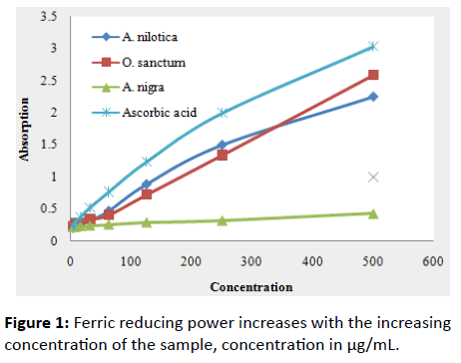
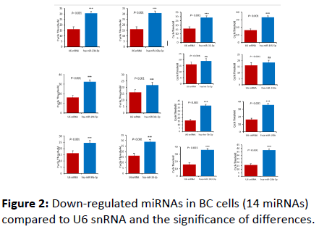

Place your image here Place your logo here
Heading Styles: The section heads in this template use the correct style (upper and lower case, bold, followed by a colon).

References: Use the brief numbered style common in many abstracts, e.g., [1], [2], etc. References should then appear in numerical order in the reference list, and should use the following abbreviated style:
[1] Author A. B. and Author C. D. (1997) JGR, 90, 1151–1154. [2] Author E. F. et al. (1997) Meteoritics & Planet. Sci., 32, A74. [3] Author G. H. (1996) LPS XXVII, 1344–1345. [4] Author I. J. (2002) LPS XXXIII, Abstract #1402.

Please DO NOT Submit Duplicates of Your Abstract; should you find it necessary to replace or repair your abstract PRIOR TO the submission deadline, return to the abstract submission portion of the meeting portal and click on the submit abstract and resubmit at the earliest.
Biography: XYZ has completed his PhD from XYY University. He/She head YYX department of XYZ organization. He/She has published more than 20 abstracts in different journals.(Word limit up to 100 words)

Presenting author details :
Full Name:
Contact number:
Email id:
Category: (Oral / Poster presentation / Workshop):
Track name:
Research interest:

